Alert Handling & Escalation
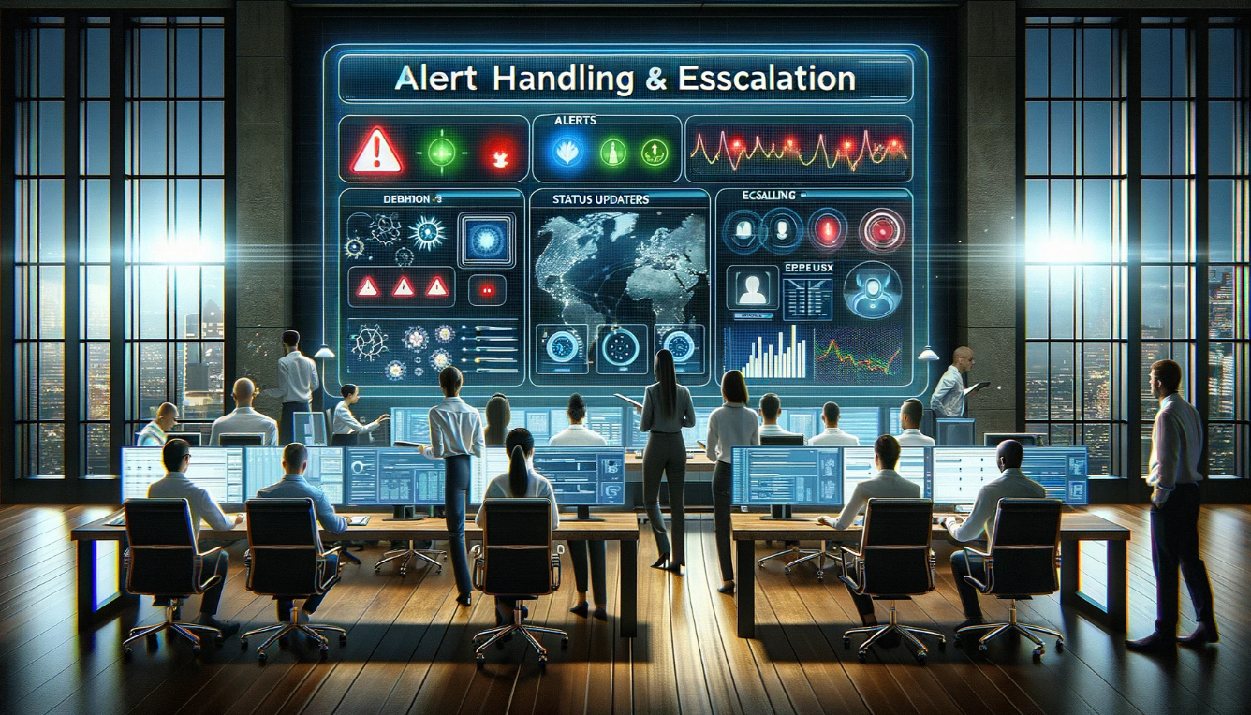

1. Purpose:
To define a standardized process for handling and escalating alerts generated by systems and tools monitored by the Managed Service Provider (MSP).

2. Scope:
This SOP applies to all alerts received by the MSP from its customers’ infrastructure, applications, and other related systems.

3. Responsibilities:
- Alert Analyst: Initial review, classification, and resolution of alerts.
- Escalation Team: Handle escalated alerts that cannot be resolved by the Alert Analyst.
- Service Manager: Ensure adherence to this SOP and continuous process improvement.

4. Procedure:
4.1 Alert Receipt
All alerts generated by monitoring tools will be directed to a central dashboard for review by the Alert Analyst.
4.2 Alert Classification
Upon receipt, the Alert Analyst will:
  - Classify the alert by severity:
  - Critical: Immediate business impact. System downtime or major functionality loss.
  - High: Significant impact but not causing immediate business disruption.
  - Medium: Minimal business impact.
  - Low: No business impact but requires attention.
4.3 Alert Handling
Based on classification:
- Critical: Immediate action is required.
  - Analyze and troubleshoot within 10 minutes.
  - If not resolved within 15 minutes, escalate to the Escalation Team.
- High:
  - Analyze and troubleshoot within 30 minutes.
  - If not resolved within 60 minutes, escalate to the Escalation Team.
- Medium:
  - Analyze within 2 hours.
  - Resolve within 4 hours or escalate.
- Low:
  - Analyze within 24 hours.
  - Resolve within 48 hours or update status.
4.4 Escalation
If an alert is escalated:
- The Alert Analyst will provide a detailed handover to the Escalation Team, including alert details, actions taken, and potential next steps.
- The Escalation Team will inform the Service Manager about the escalated alert.
- The Escalation Team will coordinate with customer contacts if external communication or actions are required.
- Post-resolution, a root cause analysis (RCA) may be performed for critical and high severity alerts.
4.5 Communication
For critical and high severity alerts, customers must be informed within 30 minutes of escalation. Regular updates should be provided every hour or as significant progress is made.

4.6 Alert Closure
Once an alert is resolved:
- Update the alert ticket with the resolution details and actions taken.
- Mark the alert as "Resolved."
- Notify the customer if the alert was previously communicated.

5. Documentation & Records:
All alerts, regardless of severity, must be logged in the MSP’s ticketing system. Records should include timestamps, actions taken, individuals involved, and resolution details.

6. Review & Continuous Improvement:
The Service Manager will review alert handling and escalation procedures quarterly to identify areas of improvement.

