HR: Employee Separation Checklist
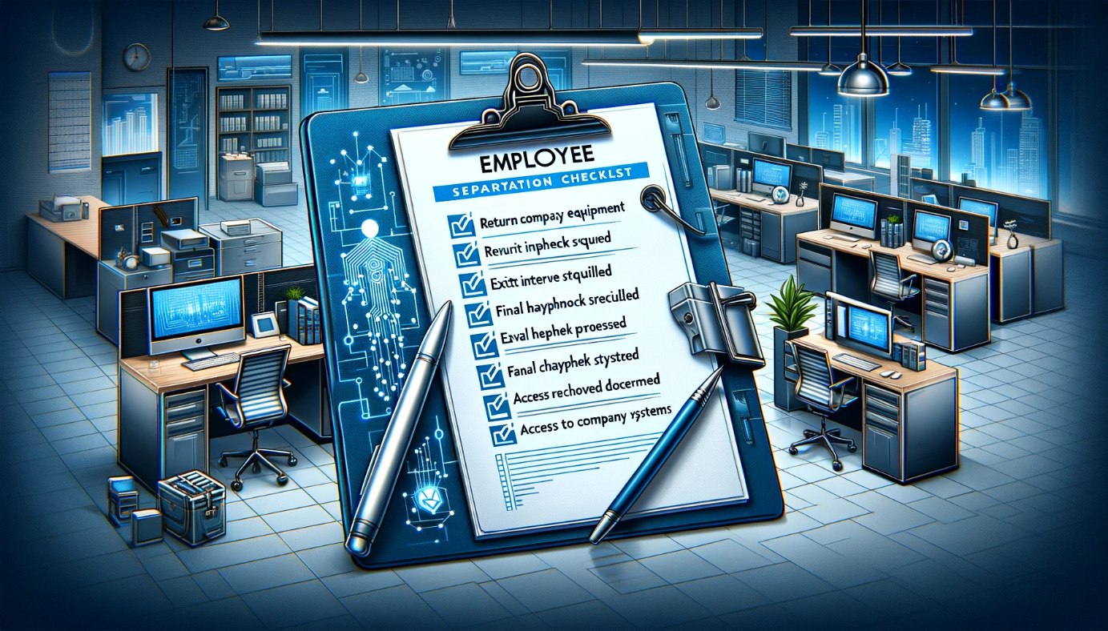

1-Objective
- Ensure a structured, consistent, and comprehensive approach to the separation of employees from our organization while maintaining confidentiality, security, and compliance.

2- Scope
- Applicable to all permanent, contract, and temporary employees separating from the organization.

3- Procedure:

Initiation
- Receive formal resignation/termination notice. Document the reason for separation.
- Confirm the last working day.

HR Formalities:
- Schedule an exit interview. Discuss the reasons for departure, obtain feedback, and address any pending concerns.
- Calculate final pay including any unpaid salary, vacation days, bonuses, or reimbursements.
- Provide details about benefits: continuation of health coverage, pension plans, and other post-employment benefits.
- Issue an experience and relieving letter.

IT Security & Compliance:
- Notify IT to deactivate all system, application, and email accounts of the departing employee on their last day.
- Revoke any VPN or remote access permissions.
- Collect all company-owned devices – laptops, phones, tokens, and any other equipment.
- Ensure the return or secure disposal of confidential data, proprietary software, and customer information.

Operational Transition:

- Coordinate with the concerned manager for a smooth handover of ongoing projects, responsibilities, and tasks.
- Retrieve all company materials – ID cards, access cards, manuals, documents, etc.
- Update the internal directory and distribution lists to remove the departing employee.

Facilities & Admin:
- Inform facilities team to revoke building and room access.
- Collect keys, parking permits, and any other physical access tools.
- Update the emergency contact list if the departing employee was a point of contact.

Communication
- Inform the immediate team and other stakeholders about the employee's departure.
- Provide redirection instructions for emails or calls for the departing employee.

Post-Separation
- Store all separation-related documentation securely.
- Periodically review the process to incorporate feedback and ensure relevance and effectiveness.

