Ticket Lifecycle
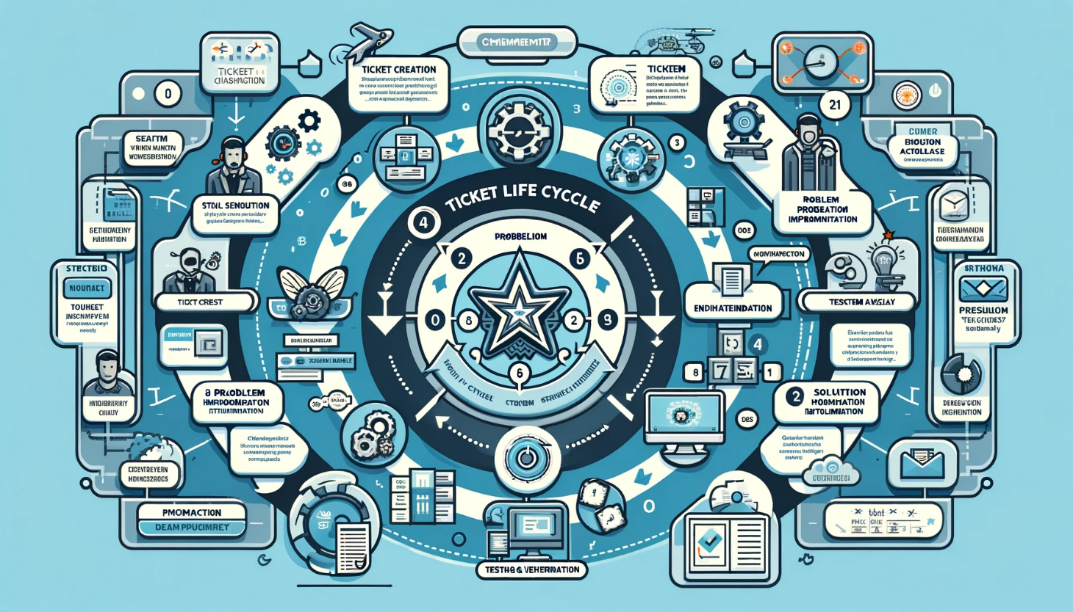

1. Purpose:
This SOP outlines the steps and procedures to be followed by team members of [Your MSP Name] for managing the lifecycle of a service ticket. This ensures timely resolution, effective communication, and consistent service quality for our clients.

2. Scope:
This procedure applies to all service tickets raised by clients and internally, from creation to resolution and closure.

3. Procedure Overview:
- Ticket Creation
- Ticket Categorization & Assignment
- Ticket Prioritization
- Ticket Escalation
- Ticket Resolution & Closure
- Ticket Review & Feedback

4. Detailed Procedure:
4.1 Ticket Creation:
- Client reports an issue via phone, email, or our online portal.
  - A ticket is created in the Service Desk tool capturing:
  - Client's name & contact details
  - Description of the issue
  - Date & time of report
4.2 Ticket Categorization & Assignment:
- Tickets are categorized based on:
  - Issue type (e.g., hardware, software, network)
  - Affected service or application
- Tickets are assigned to the appropriate technical team or individual based on expertise.
4.3 Ticket Prioritization:
  - Tickets are prioritized as:
  - Critical: System down or significant business impact. Respond within 1 hour.
  - High: Major functionality impacted. Respond within 4 hours.
  - Medium: Minor functionality issues. Respond within 8 hours.
  - Low: General queries or non-urgent issues. Respond within 24 hours.
4.4 Ticket Escalation:
- If a ticket is not addressed within the response time, it's escalated to the team lead.
- If unresolved after 48 hours, escalate to the service manager.
- Clients are notified of any escalations.
4.5 Ticket Resolution & Closure:
- Once the issue is resolved, the resolution is documented in the ticket.
- The client is informed about the resolution and asked to confirm if the issue is resolved to their satisfaction.
- If the client confirms, the ticket is closed.
- If no response from the client within 48 hours, the ticket is marked as "Pending Closure" and then closed after an additional 24 hours.
4.6 Ticket Review & Feedback:
- A feedback survey is sent to the client upon ticket closure to assess satisfaction.
- Monthly, all tickets are reviewed by the team to identify trends, recurring issues, and areas for improvement.

5. Record Keeping:
All tickets, regardless of status, are retained in the system for a period of [X years/months] for audit and quality purposes.

6. Responsibility:
- Service Desk Team: Creation, categorization, and assignment.
- Technical Teams: Resolution of tickets.
- Team Leads: Monitoring and escalation.
- Service Manager: Overall responsibility and monthly review.

7. Revision History:
- Version 1.0 – [Date]: Initial draft.
This SOP will be reviewed annually or as required to ensure its effectiveness and relevance to our operational needs.

